Sea games API test document.

1. List all events: <http://127.0.0.1:8000/api/events> (get method)
   1. Result:

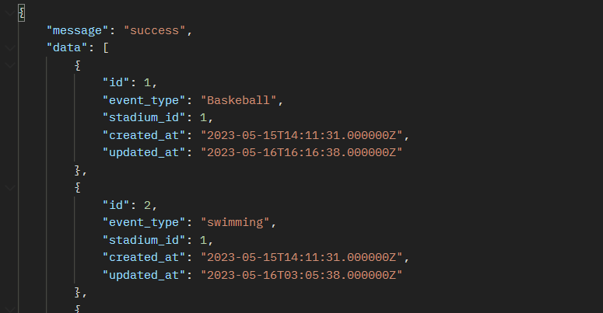

1. Search API: <http://127.0.0.1:8000/api/events> (get method)
   1. Data insert:

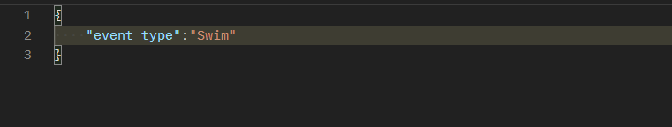

* 1. Result:

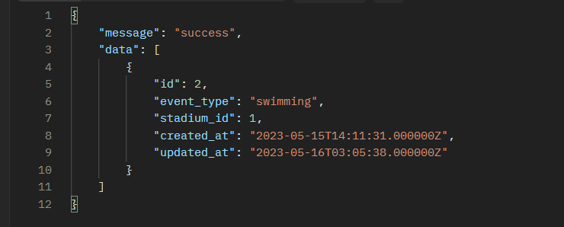

1. Delete an event: <http://127.0.0.1:8000/api/events/4> (delete method)
   1. Result:

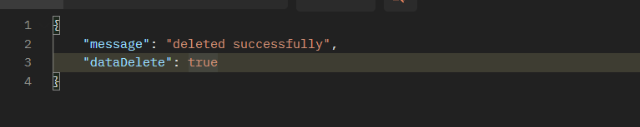

1. Buy a ticket: <http://127.0.0.1:8000/api/tickets> (Post method)
   1. What we need to insert

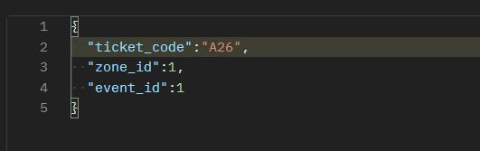

* 1. If zone id is not full, we can buy and add a ticket in database.
  2. The ticket that has inserted in database

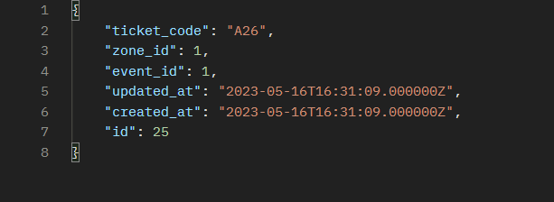

* 1. But if the zone has full, we will get the message:

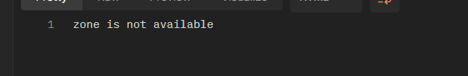

1. Update an event with the stadium information: <http://127.0.0.1:8000/api/events/1> (put method)
   1. Data need to update

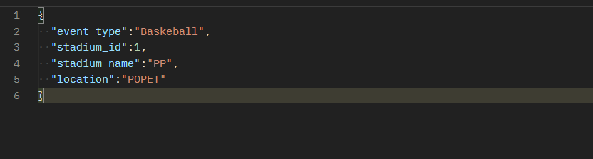

* 1. If we get the event 1 has an id of the stadium we want or do not want to update the stadium.

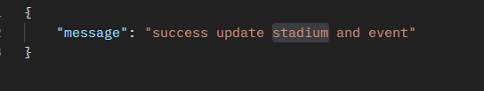

1. GitHub project repo: <https://github.com/netse24/sea_games_api.git>